**DAILY ONLINE ACTIVITIES SUMMARY**

|  |  |  |  |  |  |  |  |
| --- | --- | --- | --- | --- | --- | --- | --- |
| **Date:** | **09/06/2020** | | | | **Name:** | **Anusha. K** | |
| **Sem & Sec** | **4th SEM 'A' Section** | | | | **USN:** | **4AL18CS009** | |
| **Online Test Summary** | | | | | | | |
| **Subject** | | **No test** | | | | | |
| **Max. Marks** | | **-** | | **Score** | | **-** | |
| **Certification Course Summary** | | | | | | | |
| **Course** | **Introduction to Hadoop** | | | | | | |
| **Certificate Provider** | | | **greatlearning academy** | **Duration** | | | **4 hours** |
| **Coding Challenges** | | | | | | | |
| **Problem statement 1:**  Write a C Program to rotate the matrix by K times. | | | | | | | |
| **Status: completed** | | | | | | | |
| **Uploaded the report in Github** | | | | **yes** | | | |
| **If yes Repository name** | | | | **https://github.com/anusha20219/Lockdown-coding** | | | |
| **Uploaded the report in slack** | | | | **yes** | | | |

ONLINE TEST DETAILS: No test

CERTIFICATION COURSE DETAILS: Today I completed introduction to Hadoop certification course which covered the topics Hadoop cluster hands on, map reduce hands on, map reduce word count code. And I attempt the quiz and got the certificate.

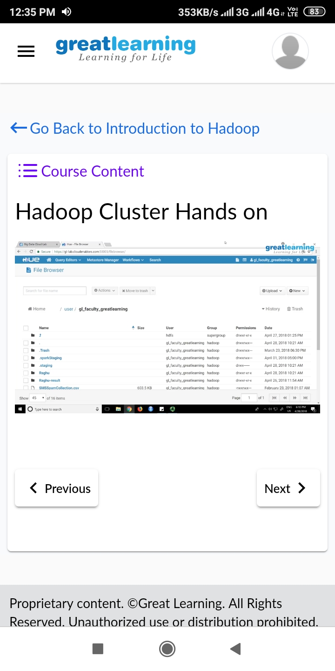

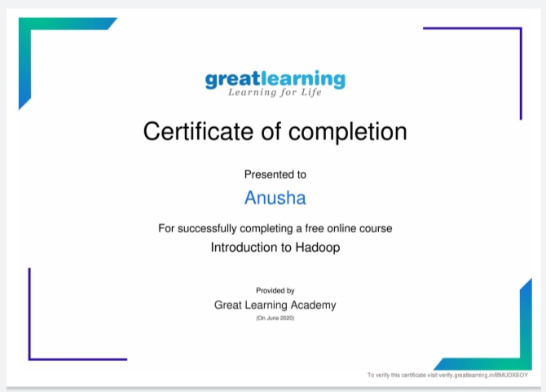

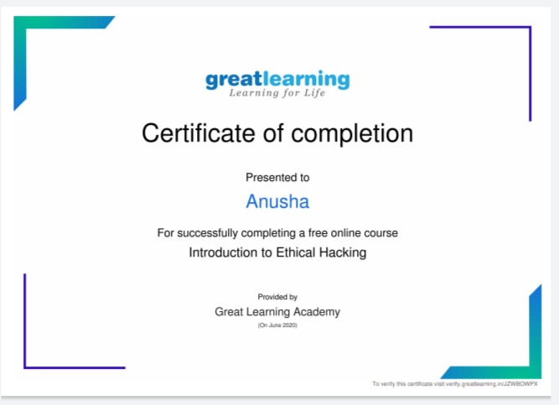

Coding challenge details:

Problem statement 1:

Write a C Program to rotate the matrix by K times.

